Chemistry
Unit 1
Area of Study 2 Test Answers:
Combining elements
Section 1: Multiple choice 29% (10 marks)
Question 1
C Ionic bonding involves the transfer of electrons between two different atoms, not the sharing.
Question 2
C 2 moles of NaOH
Question 3
D X2Y3
Question 4
B 12
Question 5
B CO32–(aq), SO42–(aq), HCl(g)
End of section 1

Section 2: Short answer 71% (24 marks)
* indicates 1 mark
Question 6
a Na2SO4
b Ca3(PO4)2
c ammonium carbonate
d diphosphorous heptoxide
(4 marks)
e
PH3 | 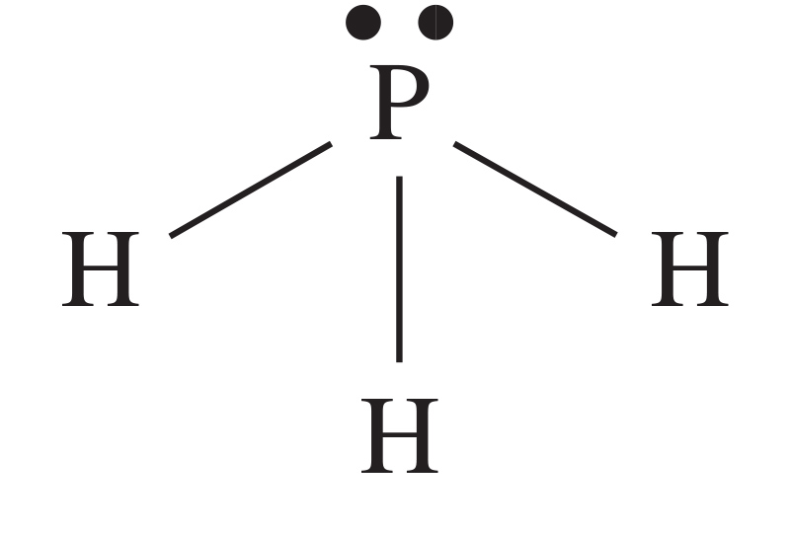
OCl2 | 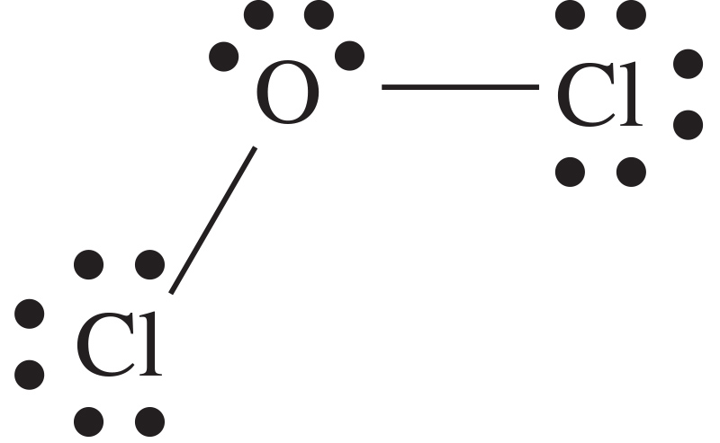
Ba(NO3)2 | 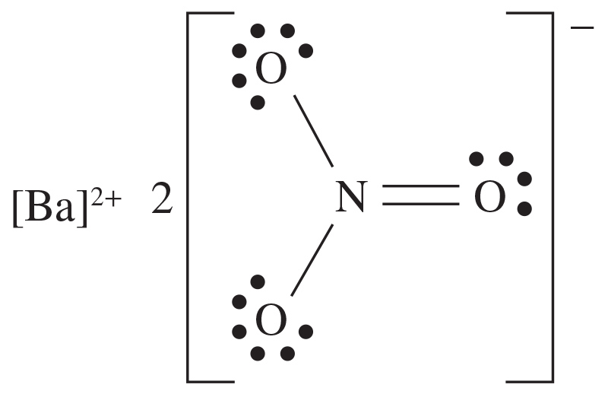

(7 marks)
Question 7
a Calcium chloride is an ionic compound consisting of a regular lattice of Ca2+ and Cl– ions, fixed in position*.
When it is struck with a hammer, like charges align and repel*.
This breaks apart the crystal structure, causing the lattice to shatter*.
(3 marks)
b In the calcium chloride crystals, the ions are fixed in position*.
Because there are no mobile charged particles, the salt does not conduct electricity*.
(2 marks)
c In the molten state, the Ca2+ and Cl– ions are free to move past each other*.
Because there are now mobile charged particles, the liquid conducts electricity*.
(2 marks)
Question 8
Ice is a covalent molecular substance.
When it melts, only the weak intermolecular forces between molecules need to be broken*.
To decompose, it is necessary to break the strong covalent bonds between hydrogen and oxygen atoms*. This requires a greater amount of energy.
(2 marks)
Question 9
Table salt is an ionic substance and sugar is a covalent molecular substance*.
When dissolved in water, salt crystals dissolve to form a solution containing Na+ and Cl– ions that are free to move*.
When sugar dissolves in water, molecules separate from each other and a solution containing C6H12O6(aq) molecules is formed*.
Salt water contains mobile charged particles and a sugar solution does not*, therefore salt water will conduct electricity and a sugar solution will not*.
(4 marks)
End of answers

