Chemistry
Unit 1
Area of Study 3 Test Answers:
Introducing organic chemistry
Section 1: Multiple choice 23% (10 marks)
Question 1
B I, II and IV
Question 2
D 4
Question 3
D They can undergo the same chemical reactions.
Question 4
B propene
Question 5
D 2,2,3-trimethyl pentane
End of section 1

Section 2: Short answer 77% (34 marks)
* indicates 1 mark
Question 6
Name | Structural formula
3,3-dimethyl hexane | 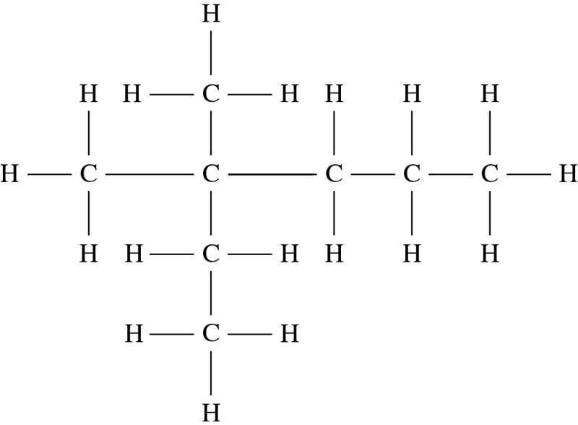
2,3-dimethyl but-1-ene | 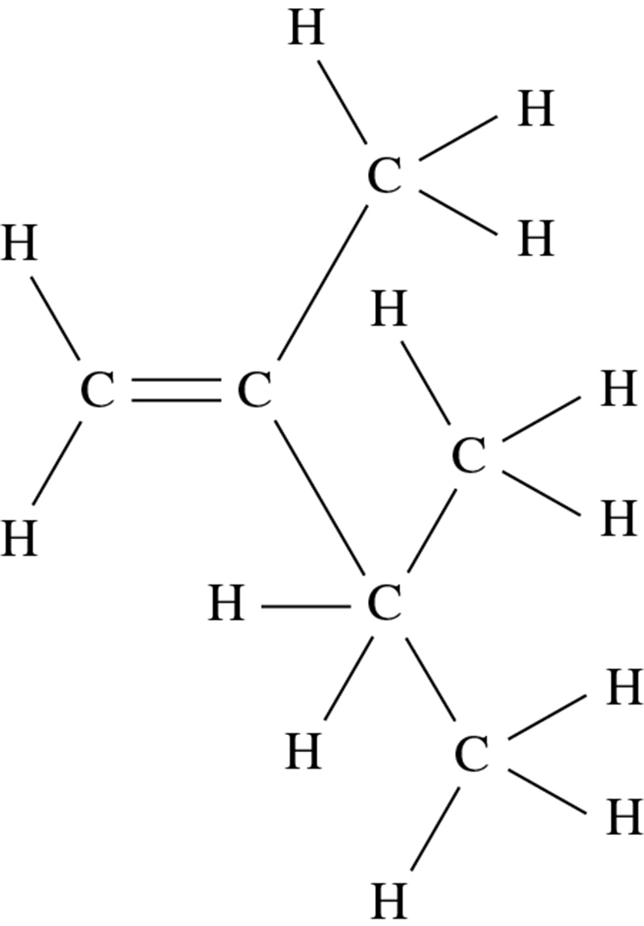
trans pent-2-ene | 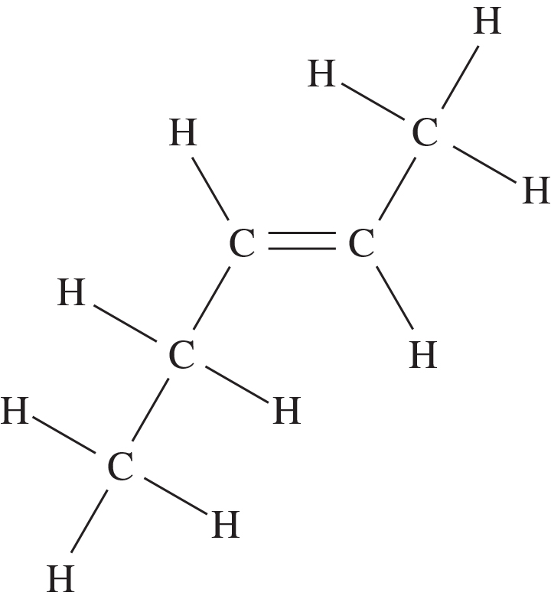
methyl benzene | 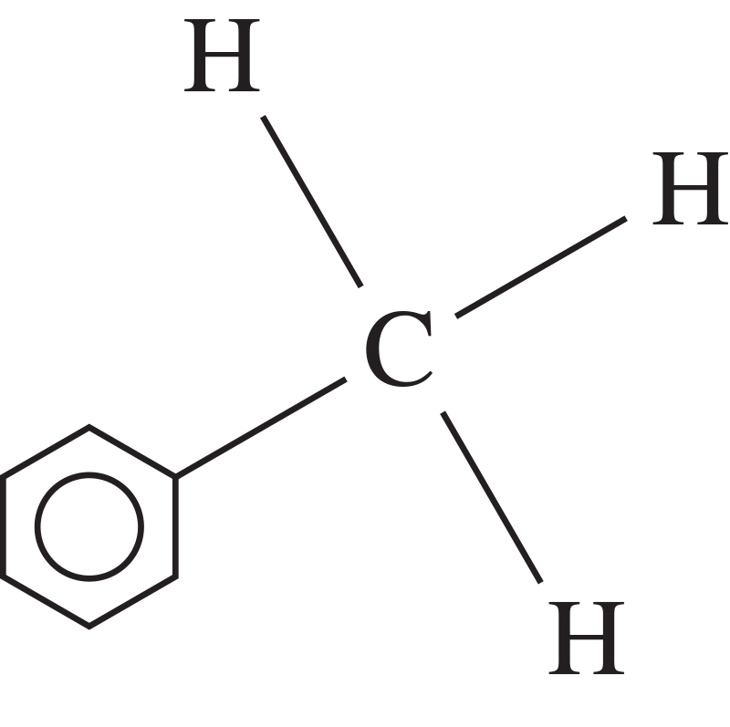
(8 marks)

Question 7
Description | Structural formula
an isomer of pent-1-ene that displays geometric isomerism | 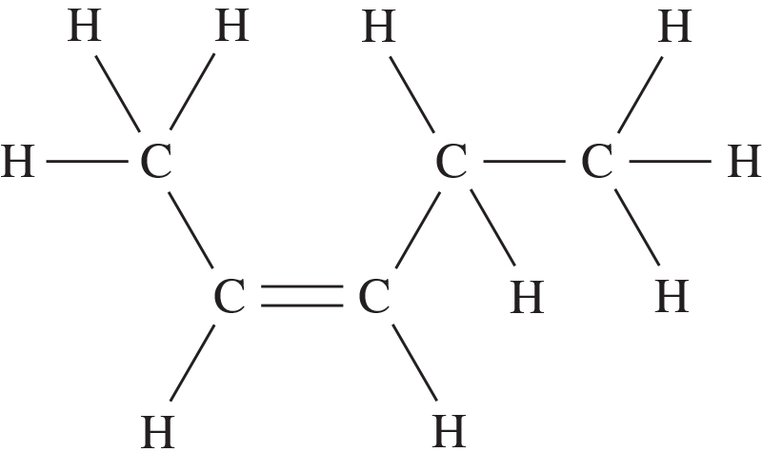  or the trans isomer
a molecule with molecular formula C2H2Br2 that does not exhibit geometric isomerism | 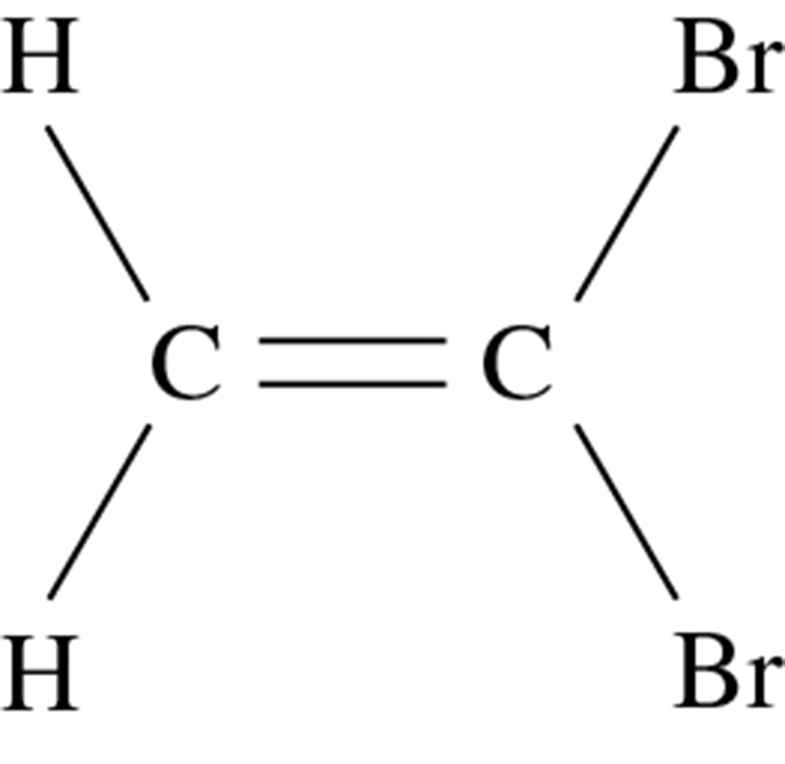
an aromatic compound with 8 carbon atoms | 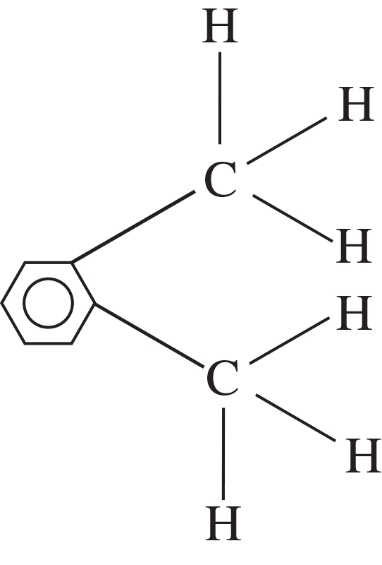  or many other possibilities
the product of adding bromine water to but-2-ene | 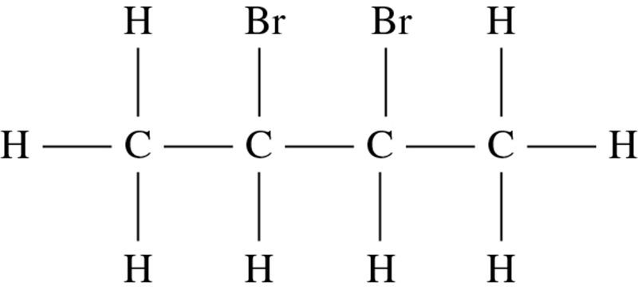
an organic product formed in the reaction between ethane and chlorine in the presence of UV light | 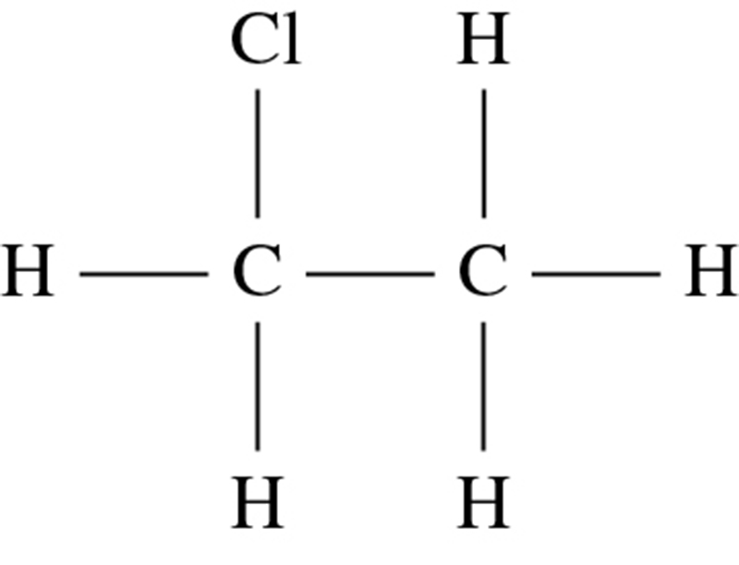  or a more heavily substituted ethane
(10 marks)

Question 8
Both diamond and graphite are covalent network substances*.
In diamond, carbon atoms are covalently bonded to 4 other carbon atoms in a continuous tetrahedral structure*.
In graphite, carbon atoms are covalently bonded to 3 other carbon atoms in a planar hexagonal structure*.
There are no delocalised electrons in diamond, but there are delocalised electrons (1 per atom) between layers of atoms in graphite*. These delocalised electrons are able to conduct charge through graphite.
Diamond  must show each carbon bonded to four others*  1 mark for labelling | Graphite  must show each carbon bonded to three others in planar structure and delocalised electrons between layers*  1 mark for labelling
(8 marks)
Question 9
a Ethane as a starting material
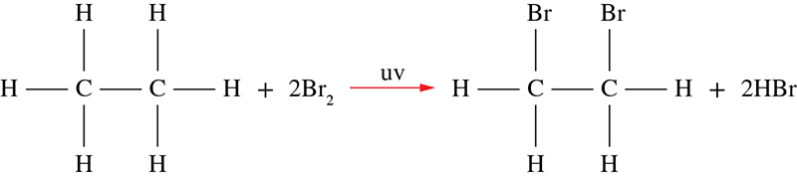
(2 marks)
Ethene as a starting material
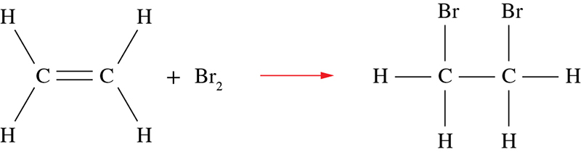
(2 marks)
b Starting with ethane: substitution
Starting with ethene: addition (2 marks)
c An orange solution is decolourised (becomes colourless). (2 marks)
End of answers

