Chemistry
This sample test paper has been prepared as part of the Pearson suite of resources for the Year 11, Unit 1, ATAR Chemistry Course prescribed by the Western Australian School Curriculum and Standards Authority.
Unit 1
Area of Study 3 Test:
Introducing organic chemistry
Time allowed
Reading time: 5 minutes Working time: 40 minutes
Materials required
An approved non-programmable calculator.
Chemistry Data Booklet. This may be downloaded from the SCSA website.
Structure of this paper
Section | Number of questions available | Number of questions to be answered | Suggested working time (minutes) | Marks available | Percentage  of total test
Section 1:  Multiple choice | 5 | 5 | 10 | 10 | 23
Section 2:  Short answer | 4 | 4 | 30 | 34 | 77
Total |  |  | 40 | 44 | 100

Section 1: Multiple choice 23% (10 marks)
This section has 5 questions. Answer all questions by circling the correct option. Marks will not be deducted for incorrect answers. No marks will be given if more than one answer is completed for any question.
Suggested working time: 10 minutes
_____________________________________________________________________________

1 Which of the following share the same empirical formula?
I ethene
II cis pent-3-ene
III benzene
IV 2-methyl pentene
A I, III and IV
B I, II and IV
C II, III and IV
D all of them
2 How many different alkenes are there with the molecular formula C4H8?
A 1
B 2
C 3
D 4
3 Which one of the following statements about graphite and diamond is true?
A They have the same crystal lattice structure.
B They have the same degree of hardness.
C They have the same electrical conductivity.
D They can undergo the same chemical reactions.
4 The complete combustion of the hydrocarbon CxHy produced CO2 and H2O in the ratio 1:1. The hydrocarbon could be
A propane.
B propene.
C benzene.
D methane.
5 Which of the following compounds exists and is named correctly?
A methene
B C3H5
C 2,2-dimethyl propene
D 2,2,3-trimethyl pentane
End of section 1

Section 2: Short answer 77% (34 marks)
This section has 4 questions. Answer all questions. Write your answers in the space provided. When calculating numerical answers, show your working or reasoning clearly. Express numerical answers to the appropriate number of significant figures and include appropriate units where applicable.
Do not use abbreviations, such as ‘nr’ for ‘no reaction’, without first defining them.
Suggested working time: 30 minutes
_______________________________________________________________________________

Question 6 (8 marks)
Complete the following table.
Name | Structural formula
 | 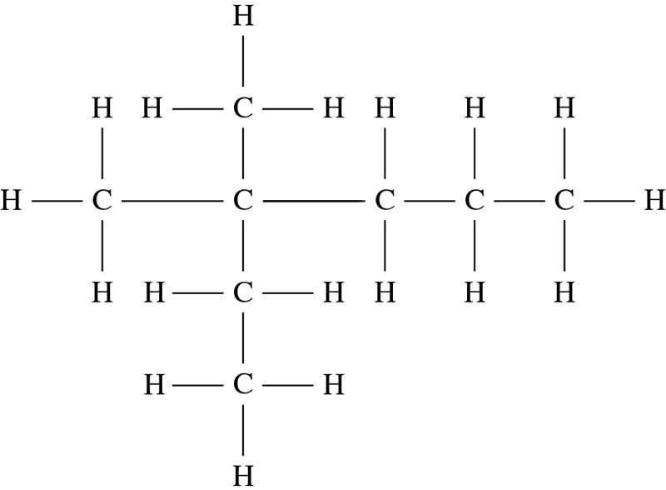
2,3-dimethyl but-1-ene
 | 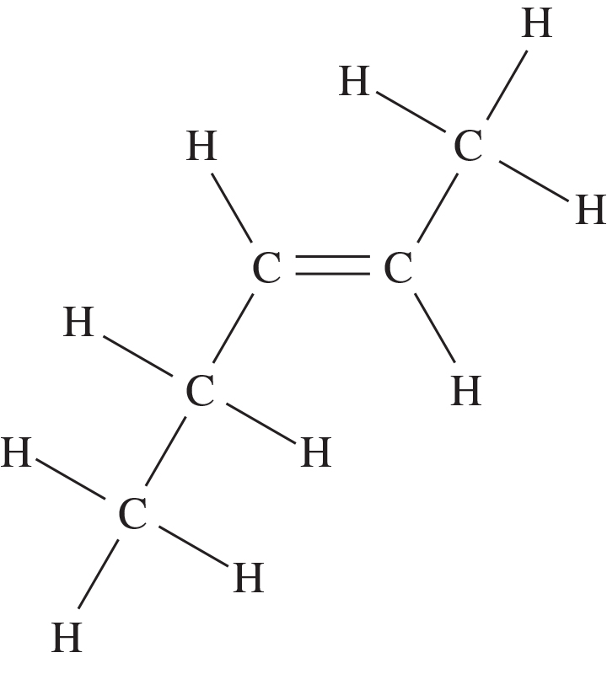
methyl benzene

Question 7 (10 marks)
Draw the full structural formula of compounds that fit the following descriptions.
Description | Structural formula
an isomer of pent-1-ene that displays geometric isomerism
a molecule with molecular formula C2H2Br2 that does not exhibit geometric isomerism
an aromatic compound with 8 carbon atoms
the product of adding bromine water to but-2-ene
an organic product formed in the reaction between ethane and chlorine in the presence of UV light

Question 8 (8 marks)
Carbon can exist in several allotropes. Explain why diamond is not an electrical conductor, but graphite is able to conduct electricity. Include labelled diagrams of both structures in your response.
___________________________________________________________________________
___________________________________________________________________________
___________________________________________________________________________
Diamond | Graphite

Question 9 (8 marks)
1,2-dibromoethane (CH2BrCH2Br) can be produced using different reaction pathways. Both ethane and ethene can be used as starting materials.
a Write equations using structural formulas to show how CH2BrCH2Br can be formed from both ethene and ethane. (4 marks)
Ethane as a starting material
Ethene as a starting material
b Name the type of reaction represented in each equation above. (2 marks)
Starting with ethane: ________________________________
Starting with ethene: ________________________________
c Give an observation for the reaction starting with ethene. (2 marks)
___________________________________________________________________________
___________________________________________________________________________
___________________________________________________________________________
End of questions

