C5b Electrolysis
Electrolysis of Molten Compounds
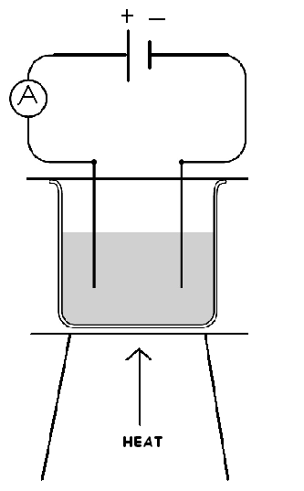

- A compound is heated until it ____________ and an ____________________ _______________ is passed through it.
- For the circuit to be complete _______________ must flow.
- The ________________ electrode (anode) attracts _____________ ions (anions) and takes electrons away from them.
- These flow through the external circuit to the ________________ electrode.
- The _____________________ electrode (cathode) gives electrons to the ___________________ ions (cations) that it has attracted.
- As ions gain or lose electrons they become ________ or ________________ and are discharged from the solution.

Metal ions are always __________________________
e.g. H⁺ Li⁺ Na⁺ K⁺ Rb⁺ what do the last 4 have in common? Pb²⁺ Fe²⁺ Mg²⁺ Ca²⁺ Sr²⁺ what do the last 3 have in common?
Non-metal ions (except hydrogen, H⁺) are ______________
e.g. F⁻ Cl⁻ Br⁻ I⁻ what do these 4 ions have in common?
O²⁻ S²⁻
Electrolysing Molten Compounds
What type of compounds electrolyse?
- Electrolysis is the ______________________ of a liquid by the passing an electric current through it.
- This can only happen if the compound decomposes to produce _______ (charged particles) i.e. ionic compounds made from a metal and __________________ part.
- The ions are then attracted to the ___________ (positive electrode) and the _______________ (negative electrode).
- Ionic compounds are usually solids. Electrolysis will ONLY take place when ionic compounds are molten because the ions must ________________ to the electrodes.

Example 1 – Consider Sodium Chloride: Cathode:
Metal ions __________ electrons to become metal atoms
Molten sodium chloride

Anode:
Non-metal ions ___________ electrons to become atoms or molecules.

We call this type of equation a ______________.

Predict the products of electrolytic decomposition of the following molten electrolytes:
Electrolyte | positive ions (cations) | negative ions (anions)
sodium chloride NaCl | sodium | chloride
Al₂O₃
PbBr₂
PbI₂
KCl

Half equations: Cathode Anode
Al₂O₃ Al³⁺ + __e⁻ Al O²⁻ O₂ + __e⁻
PbBr₂
PbI₂ ⁻
KCl
Electrolysis of Aqueous Solutions
What difference does dissolving a compound in water make?

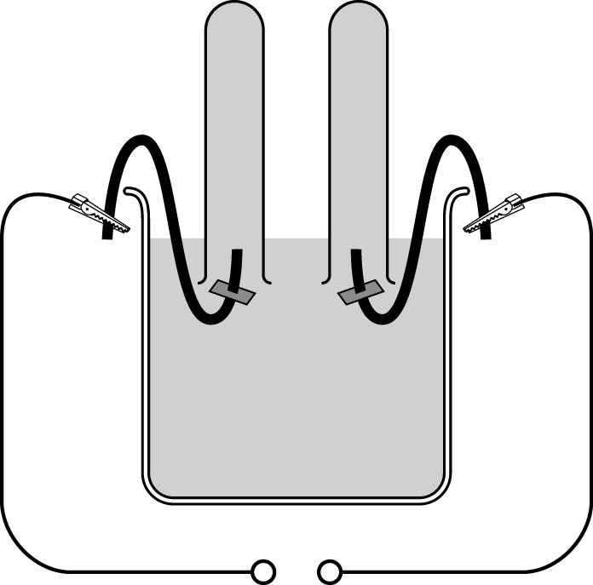
indicator paper
small test tube
electrode
power supply
crocodile
clip
+–
Consider a sodium chloride solution (salty water)

- Sometimes the ions from water are more attracted to the electrodes than the ions from the solute (dissolved compound)

- In the solution above, the ____________ ions are attracted to the anode (+), _____________ electrons and become _____________________________

- The ________________ ions from water are attracted to the cathode (-) and form _____________________ molecules, H₂.
Cathode:

Anode:

Example 2 Potassium sulfate, K₂SO_{4(aq)}
Cathode:
Anode:
Example 3 KNO_{3(aq)}
Cathode:
Anode:
Summary
The following 3 solutions all produce hydrogen and oxygen when electrolysed:
NaCl_{(aq)}sodium chloride
K₂SO_{4(aq)}potassium sulfateoxygen + hydrogen
KNO_{3(aq)}potassium nitrate
Purifying Copper using Electrolysis
Summary:
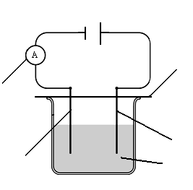
Describe the changes in mass of the copper electrodes

- The cathode (negative electrode) __________ mass
cardboard spacer
- The positive electrode (anode) ___________ mass
- The gain in mass of the negative electrode is ______________ the loss in mass of the positive electrode.
copper (II) sulfate solution
Half Equations:
Positive electrode (anode):

Negative electrode (cathode):

What factors affect the amount of copper produced during electrolysis?
- The amount of product made depends on the number of ______________ transferred
- So the ______________the current the more electrons there are. Also, the _______ the time the greater the number of electrons transferred.
more time and higher current = _______________ mass of pure copper

The relationship between charge transfer, current and time:
Units
Q = I t Q = C (coulombs)
I = A (amps)
t = s (seconds)
Example 1
0.96g of copper is deposited by a 0.5A current running for 100 minutes
a) What is the total charge used up?

b) How much charge would used in 200 minutes?
c) How much charge would be used if we increased the current to 1.0A for 100mins?

Example 2
0.48g of copper is deposited by a 0.25A current running for 100 minutes
a) How much copper is deposited by 1 coulomb of charge?
(hint: work out the total charge first and then divide the mass by the total number of coulombs)

b) If a current of 0.25A ran for 5 hours how much copper would be deposited?

A couple of harder challenges (you wont get these in a GCSE exam!)
c) If a current of 0.25A is used, how long would be needed to deposit 9.6g of copper? Give your answer in hours and minutes (not just minutes)

Example 3
A current of 5A was used for 60 minutes to produce 19.5g of lead from molten lead bromide.
a) which electrode will produce the lead?
b) give the chemical formula of the substance produced at the other electrode.
c) Calculate the total charge used in the electrolysis

d) Calculate how much lead 1 coulomb of charge could produce

f) What mass of lead would be produced if a current of 30 amps was used for 10 minutes?

e) Suggest two different ways that you could exactly double the amount of lead being produced? (see if you can prove it mathematically)

