Redox 1. - Class worksheet
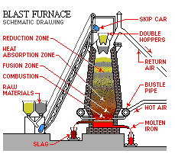

Extraction of Iron

1. What is the name and formula of the ore, found in WA, from which iron is extracted?

2. What is a blast furnace?

3. What raw materials are fed into the blast furnace
i) at the top?

ii) near the bottom?

4. a) At approximately what range of temperatures is the blast furnace maintained during the smelting of iron?

b) How is this temperature maintained?

5. a) Give the overall equation for the smelting of iron in the blast furnace.

b) What is the reducing agent used to reduce the iron(III) oxide?

c) How is this reducing produced?

6. What is the function of the limestone in the blast furnace?

7. a) What products come out of the top of the blast furnace?

b) What products come out of the bottom of the blast furnace?

8. Is the iron produced in the blast furnace very useful? Explain your answer.

9. a) How is the iron produced in the blast furnace made more useful?

b) What is the major use of iron?

c) Give examples of useful forms of iron, and their uses

Production of gold

10. In what form is gold often found naturally? Why is this?

11. Complete the following diagram showing the important stages involved in the CIP extraction of gold.
