Name: Class:
Introduction
Looking at the elements of the third period gives a good indication of some general trends in the periodic table. The following table shows some physical data for the elements of the third period.

Element and symbol | Atomic number | Atomic radius (pm = 10^{–12} m) | Melting point (°C) | Boiling point  (°C) | Electronegativity (Pauling scale)
Sodium (Na) | 11 | 186 | 98 | 883 | 0.93
Magnesium (Mg) | 12 | 160 | 650 | 1110 | 1.31
Aluminium (Al) | 13 | 143 | 660 | 2467 | 1.61
Silicon (Si) | 14 | 116 | 1410 | 3267 | 1.90
Phosphorus (P) | 15 | 110 | 44 | 280 | 2.19
Sulfur (S) | 16 | 102 | 113 | 445 | 2.58
Chlorine (Cl) | 17 | 99 | –101 | –34 | 3.16
Argon (Ar) | 18 | 71 | –189 | –186 | —

On the axes below, plot atomic radius versus atomic number for the period 3 elements. Join the points together.
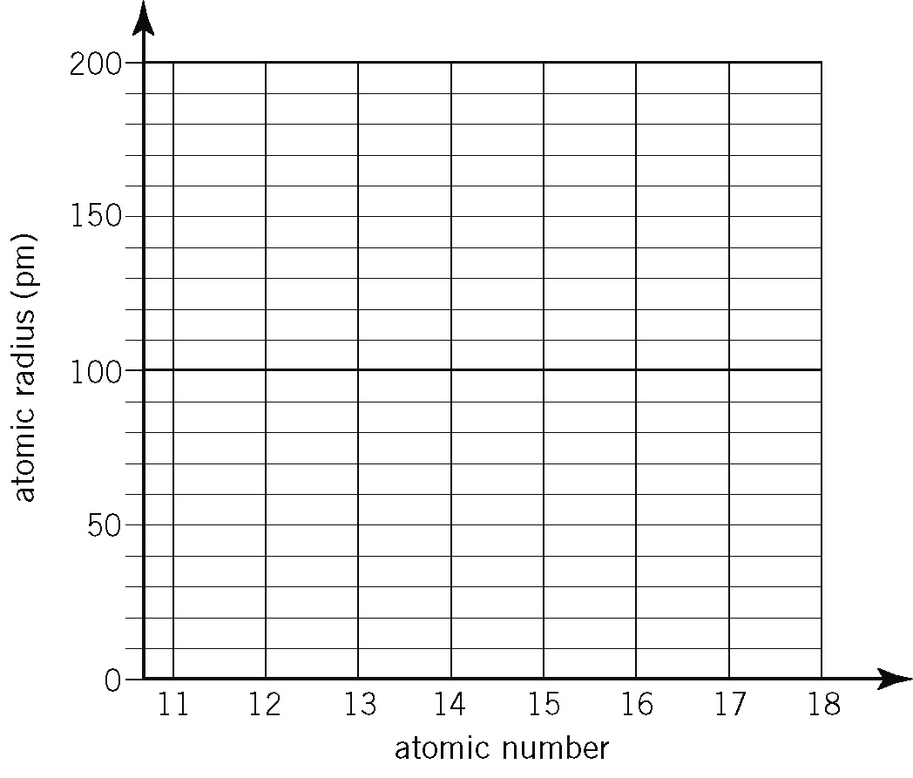

No. | Question | Answer
 | How many sodium atoms, arranged end-on-end, would have to be lined up to form a 1 cm length?
 | What trend in atomic radius, if any, is evident in the plot?
 | Suggest a reason for the trend observed.
 | Would you expect the same trend to be observed for the period 2 elements?
 | Sodium is a more reactive metal than magnesium. How does this fact relate to their atomic radii?

On the axes below, plot melting point versus atomic number for the period 3 elements. Join the points together.

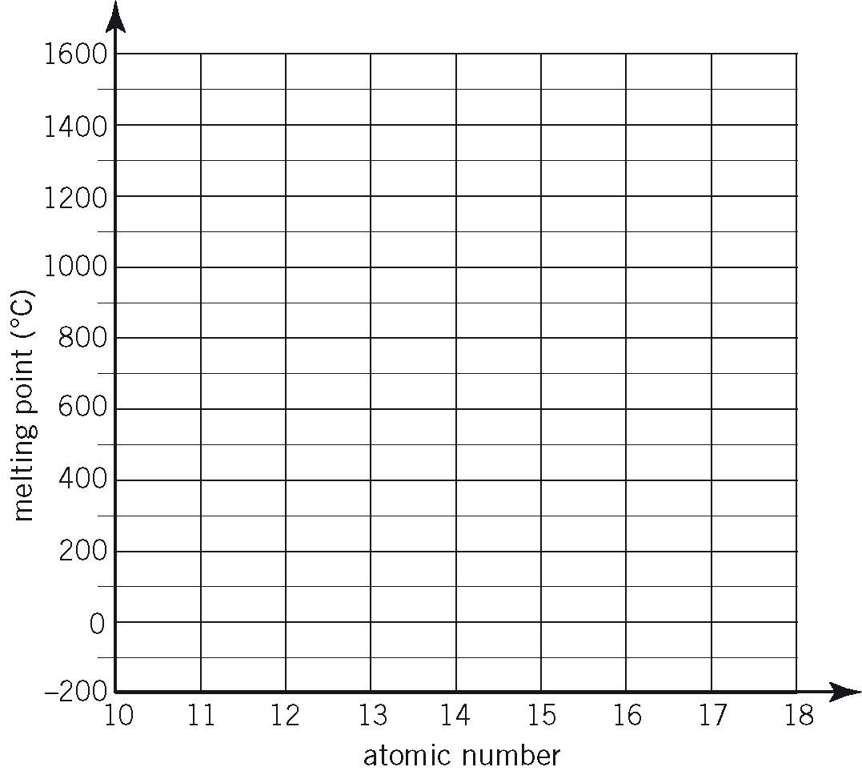

No. | Question | Answer
 | What trend in melting point, if any, is evident in the plot?
 | Suggest why the melting point of magnesium is much higher than that of sodium.
 | What state would chlorine be in at 25°C?
 | Argon has very low melting and boiling points. What does this say about the strength of the attraction between argon atoms?
 | Silicon has the highest melting point. What does this say about the strength of the bonds between silicon atoms?

On the axes below, plot electronegativity versus atomic number for the period 3 elements. Join the points together.

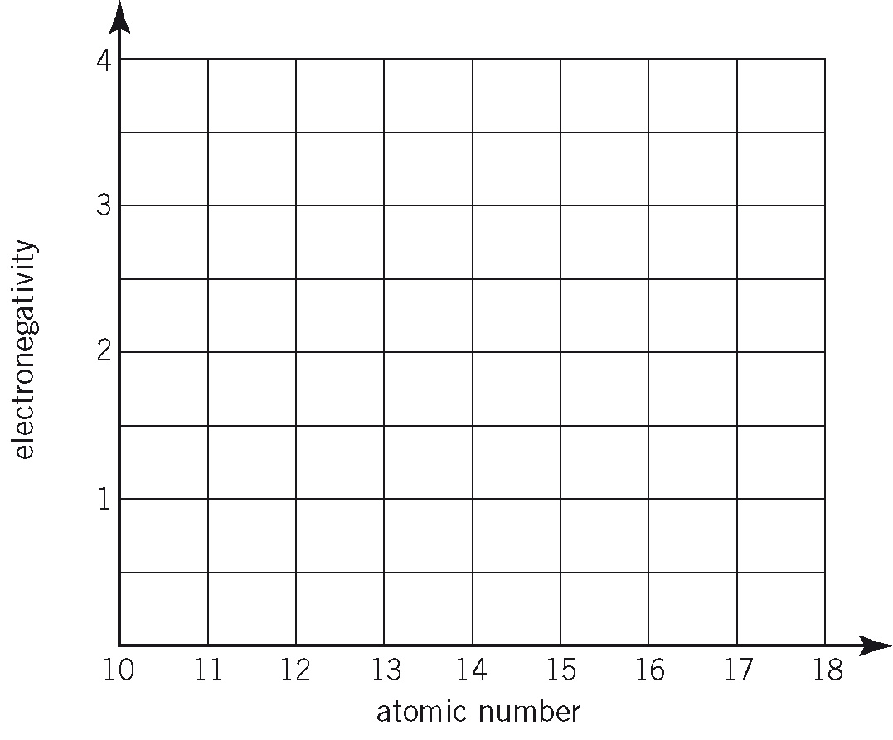

No. | Question | Answer
 | What trend in electronegativity, if any, is evident in the plot?
 | Why is it not relevant to assign an electronegativity to argon?
 | Explain why the electronegativity of silicon is much higher than that of sodium.
 | Fluorine is in the same periodic table group as chlorine. It has an electronegativity of 3.98. Explain why fluorine has a higher electronegativity than chlorine.
 | What general trend in electronegativity would you expect to see down any group of the periodic table?

