Year 12 Mastery Test
Electron Dot Diagrams

Name ______________
- Draw electron dot diagrams for the following species

a) CO₂ b) N₂

c) CaCl₂ d) CH₂Cl₂

e) CO₃²⁻ f) BF₃

g) PCl₅ h) CO

SOLUTIONS
Year 12 Mastery Test
Electron Dot Diagrams

Name ______________
- Draw electron dot diagrams for the following species

a) CO₂ b) N₂

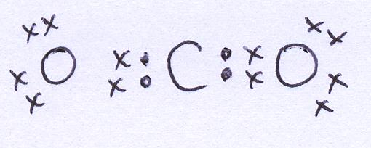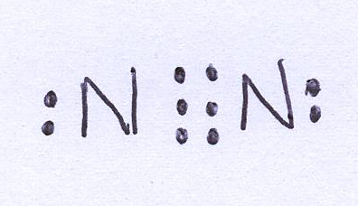

c) CaCl₂ d) CH₂Cl₂

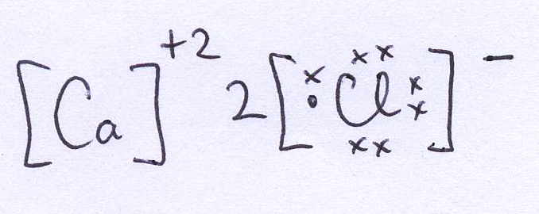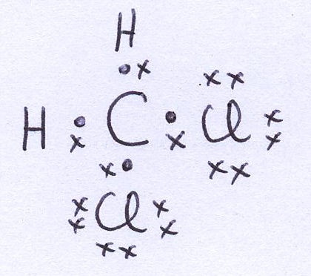

e) CO₃²⁻ f) BF₃

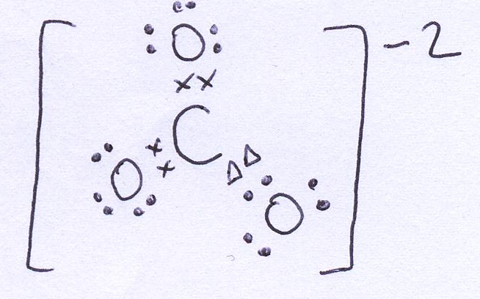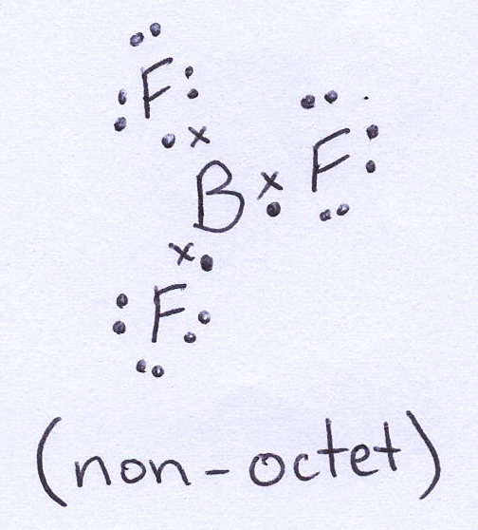

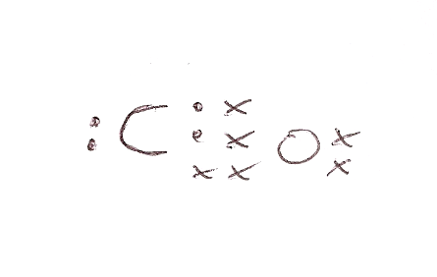
g) PCl₅ h) CO

