Year 12 Mastery Test
Electron Dot Diagrams

Draw electron dot diagrams for the following species and identify their shape

species | Dot diagram | shape
PO₄³⁻

H₂S

NO₂

CH₃Cl

C₂H₂

Cl₂

BCl₃

SOLUTIONS
Year 12 Mastery Test
Electron Dot Diagrams

Draw electron dot diagrams for the following species and identify their shape

species | Dot diagram | shape
PO₄³⁻ | 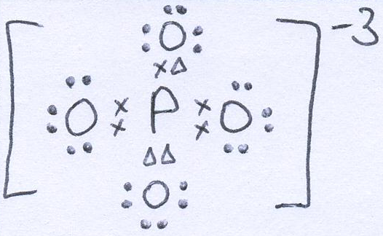 | Tetrahedral
H₂S | 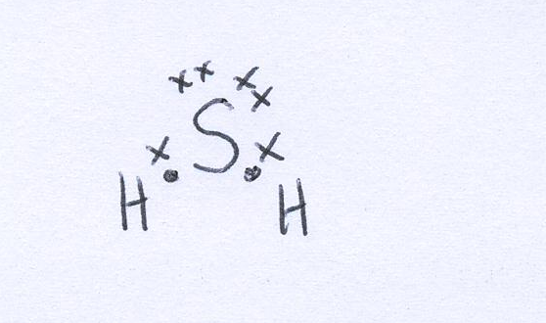 | V-shaped  or bent
NO₂ | 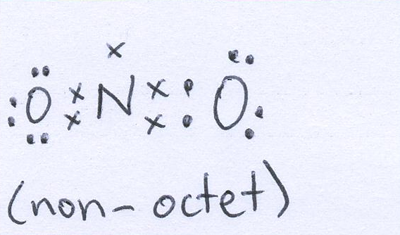 | bent
CH₃Cl | 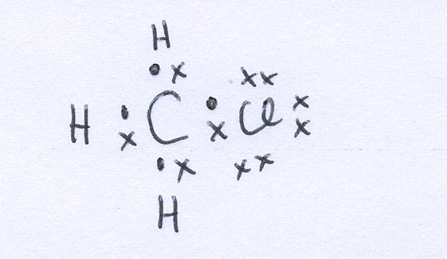 | Tetrahedral
C₂H₂ | 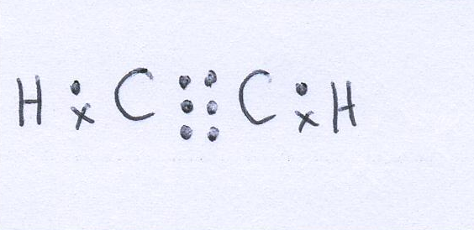 | Linear
Cl₂ | 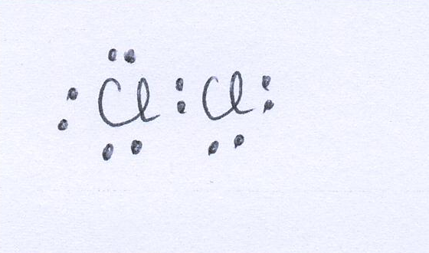 | Linear
BCl₃ | 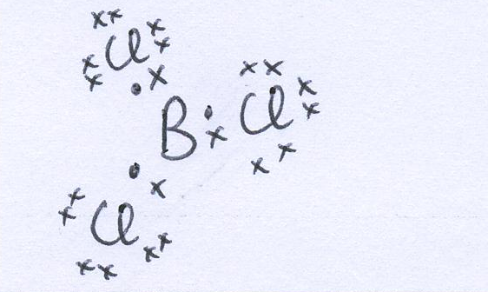 | Triangular  planar

