Year 12
Design Photography ATAR
In Class Assessment

Total time for the task: 50 minutes
/35

Question 1 (9 marks)
Question 1 (continued) (9 marks)
Figure 1: South Australian Government Bus Shelter Advertisement for Gambling
Describe the use of colour and type to convey meaning in Figure 1. (4 marks)
Colour:
Type:

Identify and describe an appropriate target audience for Figure 1. (3 marks)

Besides the Target Audience, identify two stakeholders for Figure 1. (2 marks)

Question 2 (6 marks)
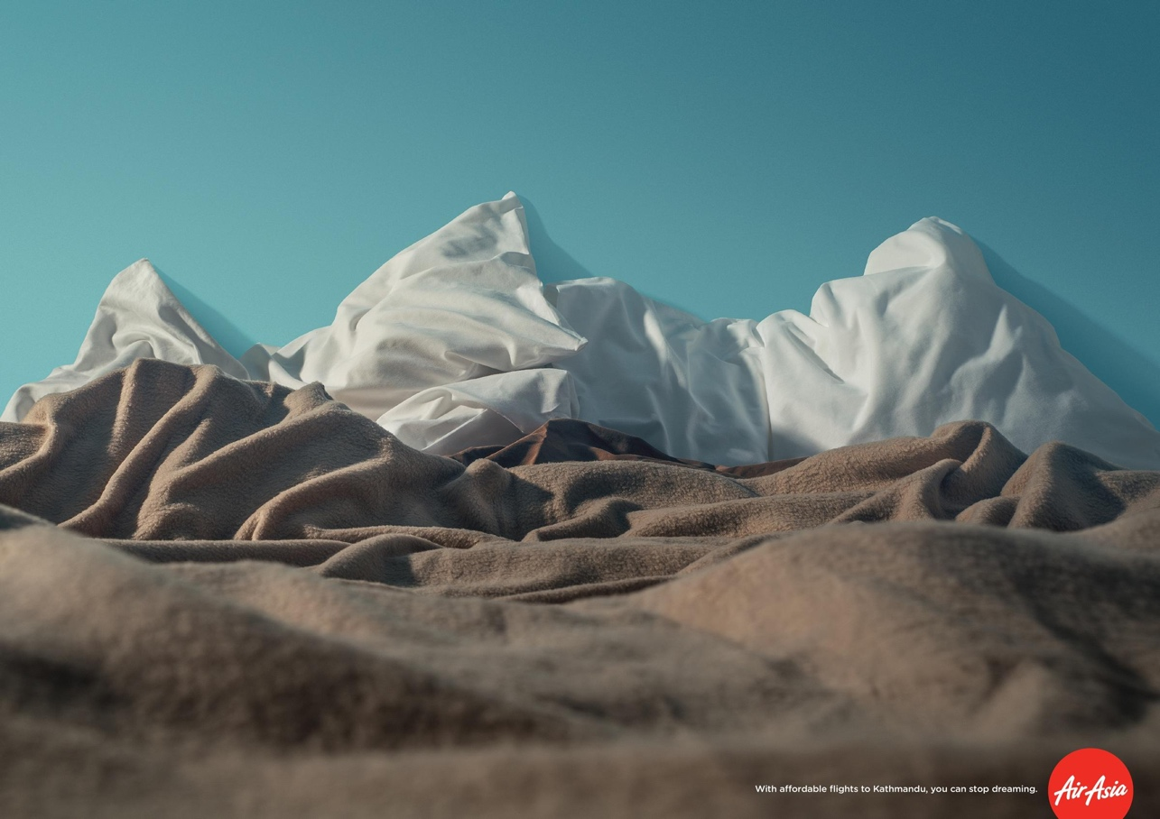

Figure 2: Air Asia print advertisement for Kathmandu.
Identify and describe how two dominant design elements and/or principles have been used effectively in Figure 2.

Question 3 (20 Marks)

The COVID19 Pandemic has limited travel for a lot of citizens, particularly people in Perth who have had closed borders for some time. Virgin Airways has hired you to create a photographic social media advertisement to entice Perth people to travel interstate. They are offering 20% off all flights from Perth to other Australian capital cities between the months of May and June 2022.

They have requested that your design:
- Should appeal to people who live in Perth and are interested in visiting a city in another state for pleasure.
- Does not need to be restricted to a still photographic image; Virgin Airways encourage mixed media, contemporary / future trends, interactivity and design elements.
- Inform viewers of the destinations available (cities interstate) and the deal on offer

- In the space below, create a detailed mind map that explores and develops ideas relevant to the design brief. (6 marks)

Question 3 continued
- In the space below, create a design solution of your concept for an photographic social media advertisement
    - Sketch a possible solution to the brief (6 marks)
    - Annotate your design to help communicate your solution (4 marks)
Question 3 continued

- Evaluate your use of elements & principles in your final design and how it fulfils the brief. (4 marks)

End of Questions
Supplementary pages
Question number:

