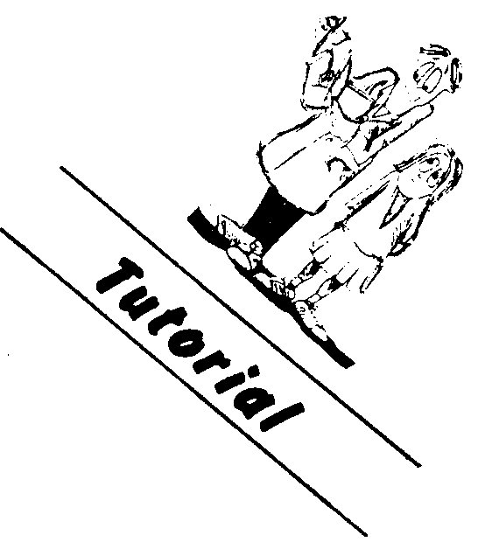
Physics
Methods of mixtures

When two substances at different temperatures are mixed one will gain heat and the other lose heat until thermal equilibrium is reached. If no heat is lost to the surroundings, then the heat lost by one object will be equal to the heat gained by the other object.

Total heat gained = total heat lost

Example
The host at a party gives you a 185 g cup of tea in a foam plastic cup. The tea is very hot at 85.5°C. You decide to cool the tea by adding 15.0°C. Calculate the resulting temperature of your drink. Assume the tea has the same specific heat as water and the cup has a negligible heat capacity.

heat lost by tea = heat gained by water

mtea cteaΔttea = mwatercwaterΔtwater

0.185 x 4.18 x 103 x (85.5 - Tfinal) = 0.0150 x 4.18 x 103 x (Tfinal- 18.0)

15.82 - 0.185Tfinal = 0.0150Tfinal -0.270

16.09 = 0.200Tfinal

Tfinal = 80.4°C

Problems
1. A mechanic adds 655 g of ethylene glycol at 22.0°C to your car's radiator. The radiator already contains 6.75 L of water at 92.0°C. If the 4.50 kg radiator is made of copper, calculate the final temperature of the mixture.

2. A maintenance worker uses steam to defrost a small freezer that contains 1.50 kg of ice at 0.00°C. Calculate the mass of dry steam at 1.00 x 102 °C he needs to convert all the ice to water at 21.5°C. Assume the heat absorbed by the freezer's plastic lining is negligible.

3. A cook pours 8.00 x 102 g of soup at 98.0°C into a 1.00 kg vacuum flask of specific heat 32.0 J kg-1 K-1. The soup raises the temperature of the flask from 10.0°C to 97.0°C. What is the specific heat of the soup?

4. You want to raise the temperature of a bath containing 40.0 kg of cold water at a temperature of 16.5°C to 45.0°C. What mass of hot water at a temperature of 75.3°C must you add to the cold water if the bath and its surroundings absorb 15% of the heat lost from the hot water as it cools to its final temperature?

5. You want to make a cool drink from some 19.7°C tap water by adding ice. Calculate the mass of ice at -11.3°C you need to cool 195 g of such tap water in a 215 g glass to a temperature of 3.60°C. Neglect any heat that your drink would gain from its surroundings.
- You find you have let a 12.0 kg stainless steel barbecue plate become much too
hot for normal cooking. You decide to cool the plate from 395°C to 185°C by spraying water onto the plate. Calculate the mass of water at 20.0°C tyou will need, assuming all the water evaporates to steam at 100°C.
a. What mass of ice at 0.00°C would have the same effect?

