Communication

Communication Styles
Communication: transmission of message from one person to another
Communication style: cultural and social manner which people share information through language.

Style effects multiple aspects of language:
- Accents
- Grammar
- Vocab
- Ideas we express

Three Basic Communication Styles
Assertive
- Ideas, feelings, belief expressed respectfully, not violating rights of others
- Emphasise importance of both needs

Aggressive
- Not respect needs, feelings, wants of others
- Body language fist clenching, crossed arms, scows

Passive
- Silent, lack respect for own ideas, place more value on others needs,feelings,wants
- Not express/defend own

Impact of Social Background
Bernstein (lang + social class)
- Diff performance between WC and MC children in language based subjects
- social class use different codes: restricted by WC and elaborated by MC
- Accounted for poor performance
- Children from WC families reduced access to EC which = language deficit
- Limit ability to benefit from education

Restricted code
- Short simple sentences, lots of information non verbal
- Much meaning makes sense w/ context
- Few descriptive words
- Command used for compliance
- here/now stressed
- Abstract idea rarely expressed

Elaborated
- Complex, precise sentences
- Clear meaning from sentence alone
- Descriptive words
- Explanation to gain compliance
- past/future referred to
- Abstract ideas, future possibilities expressed

Labov
- Research into Black English Vernacular (BEV) or African American Vernacular English (AAVE)
- AAVE just complex and rule governed as standard English, should be considered different not deficit, both convey meaning

AAEV VS Restricted code
- Both associated w/ WC
- Berstein: use RC=language deficit
- Could not benefit from standard education, inferior to MC who use both

- Labov opposed, people who use AAVE = different not deficit, similar rules of double negatives to many European languages

Malcolm
- Prejudice against styles that exist
- Looked at Aboriginal English
- Focus on difference between rules of communicating, considered Australian aboriginal expected to submit to education recognised standard english, teachers little appreciation in other styles

Gender Differences
Tannen
- Looked at differences in conversation styles that lead to breakdown of communication in men and women
- Genderlect: gender dialect
  - masculine and feminine styles of communication two distinct culture dialects rather than inferior and superior

- Women (rapport talk): seek to establish connection w/ others, avoid conflict
- Men (report talk): seek to command attention, convey information and win arguments in order to preserve status within hierarchy

Men (report)
- More air time, exchange information w/ little emotional connection
- Public w/ talk
- Language to negotiation status, avoid failure
- Talk in turn
- Gaining and holding attention
- Imparting information
- Gain and hold social status

Women (rapport)
- Establish, maintain emotional connections
- Focus on personal, small talk chats (personal experience)
- Used to talk to build relationships, maintain intimacy
- Talk over, simultaneous talk
- Develop understanding
- Establishing relationships
- Negotiating differences

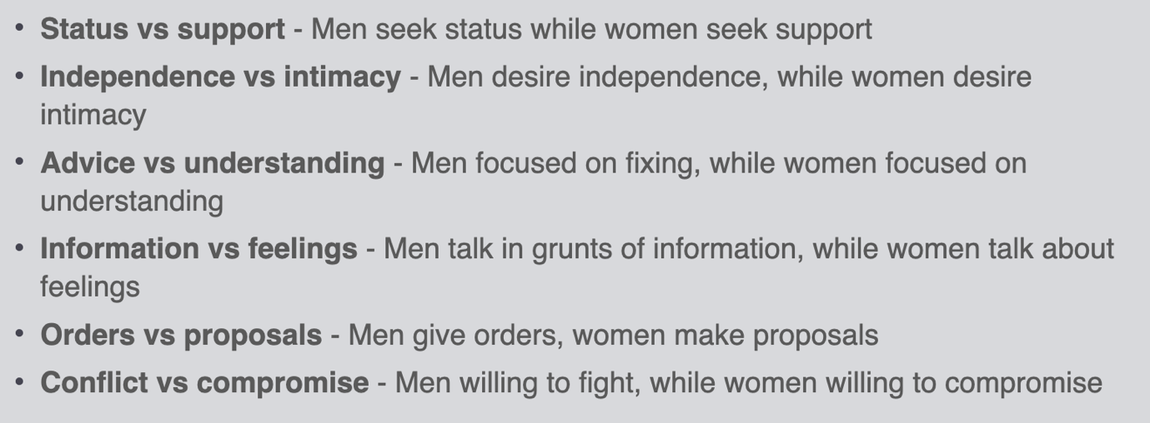

Other research for gender differences:
Listening
- Women: nods, eye contact, react w/ small response to show listening
- Interruption show agreement and solidarity
- Men: agreeing=vulnerable, women think they arent listening due to lack of agreement

Conflict
- Men: comfy w/ confrontation, chance to win argument
- Women: avoid, threatens connection

Requests
- Women: indirect, soft
- Men: direct

Criticisms
- Both gender=high value on comfort communication
- Difference in gender styles of power/status in society

Theories of Language Development

Learning Theory
Language acquisition learnt through principles of learning e.g. classical and operant conditioning, observational learning

Skinner: children learn through parents reward/punishment

Bandura: by observation and imitation

Criticisms
- Not possible for parent to reinforce/punish all possible utterance
- Studies of parents-child interaction show parent reward grammatically incorrect utterance that are truthful
- Language children hear contain too few examples for them to learn correct rules

Nativist Theory

Chomsky
- Language product unlearned, biological based, internal mental structure
- Rules which underlie language too complex to be acquired in few years, some aspects innate
- biologically programmed/predisposed to gain knowledge
- Children equipped w/ set of innate hypotheses which guide attempt to learn rules of language
  - Reduce complexity of learning language

Language acquisition device (LAD)
- Theoretical black box hard wired for language
- native input around child, generate sentences same language output
  - Universal rules distinguish grammatical from ungrammatical sentences (all languages) predisposed learn universal grammar + language
  - Two types grammatical rules:
  - Surface structure: vary between languages (determined by parameter setting for native language:)
  - Deep structure: apply to all spoken languages
  - determining SS rules or parameter ones native language parameter setting

Criticism
- Linguistic fail to specify nature of universal grammar
- Grammar not learned as rapid as expected if innate knowledge assumed
- Little neurological evidence to support existence of LAD
- Lack of attention to social factors

How would an English-speaking child will put the object of a sentence last (He drove a car) and a Japanese speaking child will put the object before the verb (He a car drove)?

Universal grammar: all human languages have same grammatical building blocks (nouns, verbs, subjects, objects) set of linguistic parameters for every language
- No language unlearnable, believe we had LAD
- All born with ability, however learn to generate sentence with environment
- Both have universal principles but environment grew up in designed what order they’re delivered

Interactionist Theory
- environment and biological factors
- Importance of social support from parents and social contexts

Bruner
Language Acquisition Support System (LASS)
- Parent provide child with LASS
- strategies parents use to provide feedback to facilitate language learning

- Scaffolding
- Deliberate use of language at level beyond what child can comprehend
- Operate one step ahead, encourages to reach step before moving to next
- Lead to child to acquire complex on own
- Framework to support language
- E.g. child say uh, point to ball, educator say buh until child say buh then say ball.
- E.g. expansion and recast: when adult take child utterance and expands on its complexity. Child might say ‘eated’, parent expand saying yes, he ‘ate’ his dinner.
- Recast: correcting grammatical form of utterance

- Infant-directed speech
- Parent speak in higher pitch, stress important words, talk slow (get attention, increase understanding)

- Reference
- Use of language or non-linguistic means to manage and direct attention
- Take as cues, direct attention
- E.g. book reading: point then ask to name object (turn head, pointing, words like here and this)

- Joint attention
- Sustained eye contact between parent/child, or parent and child and object, encourage language development
- Eye contact gained then place on object between so both paying attention
- Then name object

Criticisms
- Devilliers and De villiers suggest parent rarely offer child direct feedback on appropriate grammar
- Linguistic and social practises vary across cultures, some use none of practises and still learn at rate of western child

Chomsky nativist vs Bruner interactionist
- Chomsky: language innate/biologically predetermined and result of nature
- Burner: language developed occurred due to parent interaction and learning, believing nurture that developed language

Persuasive Communication
- Attempt to change beliefs, feelings, behaviours of another

Petty & Cacioppo
Elaboration-likelihood model of persuasion
Both important in persuasion
Central route:
Thoughtful consideration of content of message by receiver as active participant in process of persuasion
- receiver has motivation and ability to think about message
Peripheral route:
listener decides whether to agree w/ message based on cues other than content of message (shortcut)
- More passive than central processing
- Not motivated with ability to think about content

Elements to Persuasive Communication

Source of the message
Likely accept word of expertise in area, without accessing validity of claim
- Expertise: accept word with expertise in area even without assessing validity, someone knowledgeable in their area
- Fast talker: general gist understood, listener assume fast speaker more intelligent/knowledgeable, suggest due to receiver unable to evaluate content properly
- Trustworthy: confident that expert of high trustworthiness, may forgo task of scrutinising message and instead accept conclusion as valid. If unsure, feel need to scrutinise arguments, ascertain if communication is valid.
- Lawyer, doctor etc likely to be truthful

Nature of communication
Understand message and respond favourably, likely persuaded
- what is the content and delivery method (what is said and how it is said)
- Comprehension on printed ads higher than information on TV
Keep it simple: understand info present
Emotional response (positive): good mood, want to listen
Emotional response (Negative): fear, sufficient enough to make them anxious, not too provoking to make them miss the message or avoid

Characteristics of the audience
High VS low need cognition - Cacioppo and petty
High needs: persuaded by strong argument ( weigh pros/cons), unmotivated by weak
Low needs: pay attention to peripheral cues (expertise of person delivering msg)

Gender
Female tentative source to persuade male receiver
Male source equally persuasive to both

Age
oung, speech with colloquial language not patronising and above them

Pre-existing strong opinions: less likely persuaded

Culture
Min sun kim
diff cultures use diff techniques to persuade, based on study between individualist and collectivist cultures with students from mainland USA, Hawaii, Korea etc
- Collectivist: participants valued interdependence (collectivist) would likely use hint strategies to persuade (Hawaii)
- Individualist: respond to direct statements (USA)

